CS 5402 Assignment 4

Wei Luo

1. **Nonlinear transform and overfitting**

In this task, the propose is to analysis the influence when overfitting happened based on comparing the line of g(x) with the ground truth and their squared error cost.

When Q = 10, the overfitting happened. The result is below.

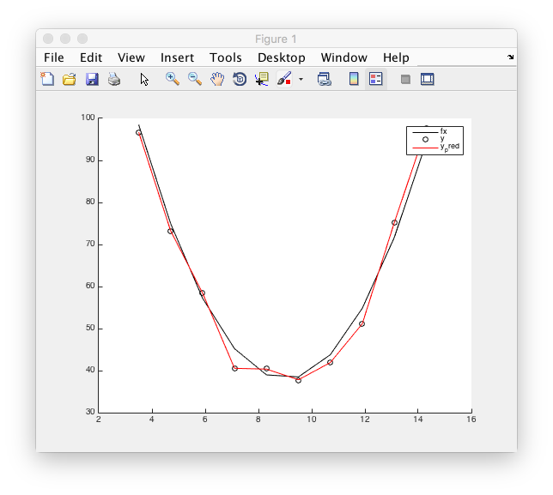

With a very good error cost err_sqr = 0.0408, the line past all the 10 points, but it is not closed with the ground truth “fx”. The result with Q = 2, even the err_sqr = 51.1182 is higher, but it is more closed to the ground truth.

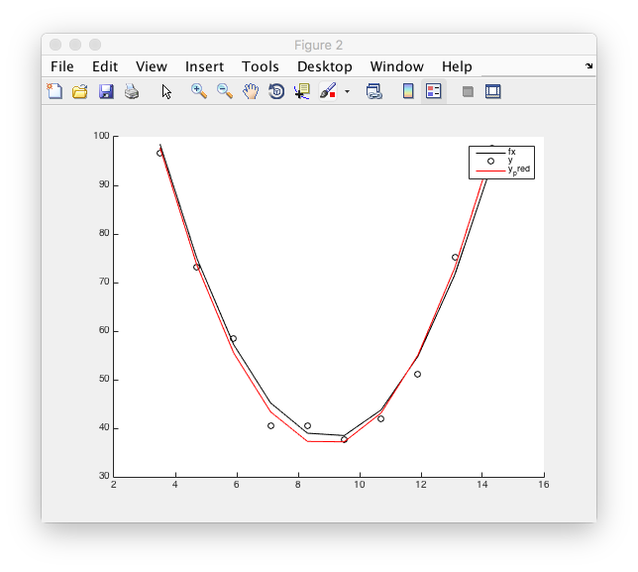

1. **Regularization**

This task I think is to show the importance of regularization to linear regression of nonlinear. In the first case, there is not any regularization here, so lambda is 0. The result is here.

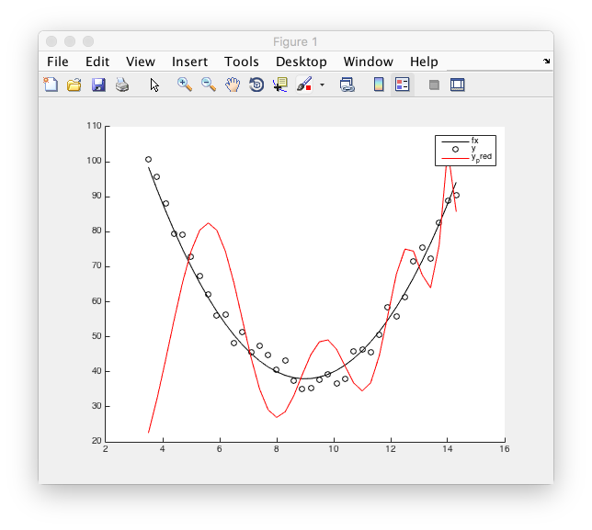

As you see, the result is so far away from the ground truth, and of course, the err_sqr is so large as 1.7054*10^4, because of the overfitting. Then we set the lambda as 0.001, so there is some regularization here. The result is below.

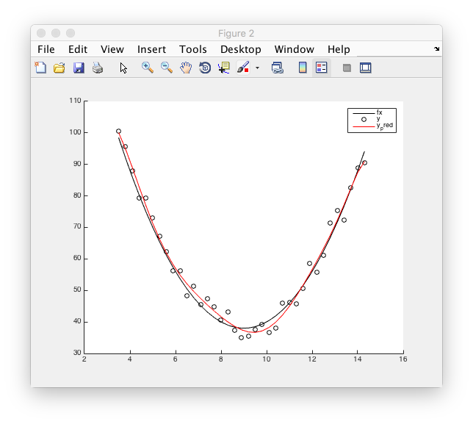

With err_sqr equals to 188.9147, which is much better than the front one.

1. **Leave-one-out cross validation**

This is the bonus point. In the leave-one-out cross validation, we compute the mean of each results with the sum of test errors with regularization. So when lambda is in {0.00001, 0.0001, 0.001, 0.01, 0.1, 1} these six cases, the results are here.

|  |  |  |  |  |  |
| --- | --- | --- | --- | --- | --- |
| 0.00001 | 0.0001 | 0.001 | 0.01 | 0.1 | 1 |
| 63.708421581100 | 48.934884212650 | 31.239380609713 | 29.669939953590 | 33.935505948556 | 131.76047385449 |

So that, we can get the result that it is better to set the lambda 0.01 here. But actually, in matlab 2015a, the result would be different. In that matlab, the best lambda would be 0.001.